# GitHub Repository Settings

## Settings - Options

Only have the following enabled:

Features

* Restrict editing to users in teams with push access only
* Issues

Data services

* Security alerts
* Preserve this repository

Merge button

* Allow squash merging
* Automatically delete head branches

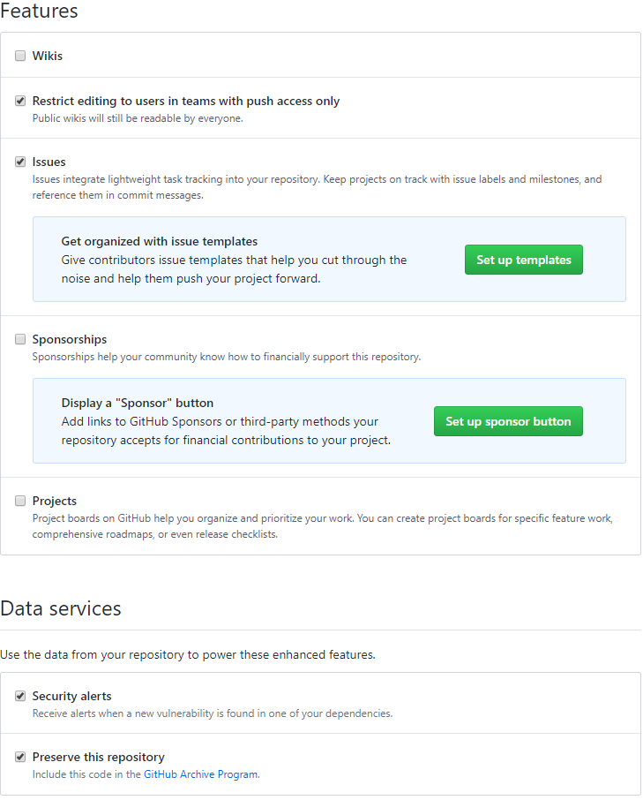

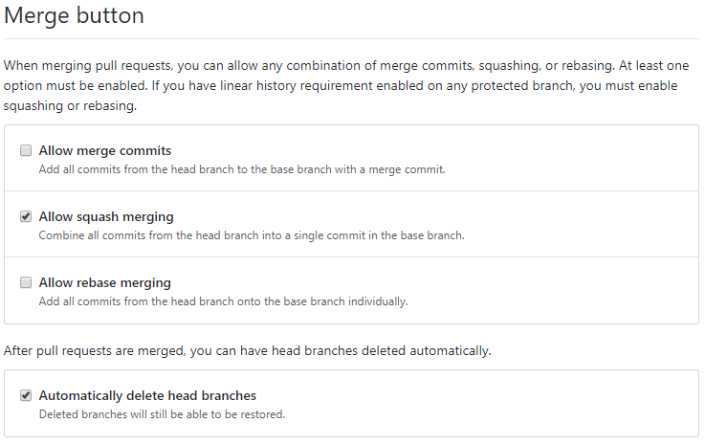

## 

## Settings - Branches

Create a new branch rule named "master"

Only have the following enabled:

* Require pull request reviews before merging
* Require status checks to pass before merging
* Require branches to be up to date before merging
* Include administrators
* Restrict who can push to matching branches

Create rule named "develop"

Only have the following enabled:

* Require pull request reviews before merging
* Require status checks to pass before merging
* Require branches to be up to date before merging
* Include administrators
* Restrict who can push to matching branches

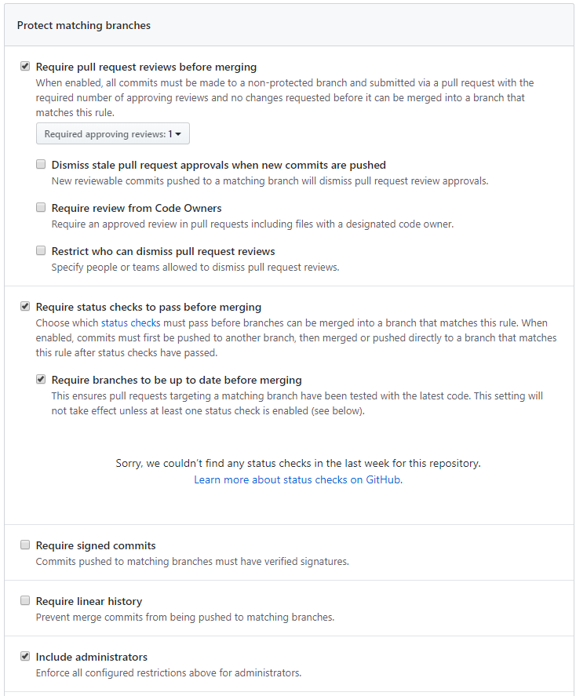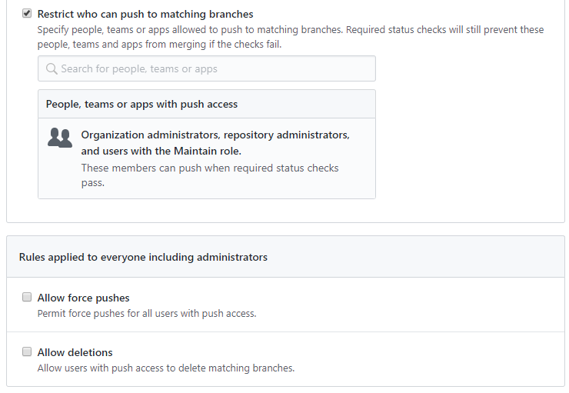

# Naming

## Branches

master

develop

feature/S65-<number>

hotfix/S65-<number>

The <number> corresponds with the Jira board story number.

## Commit Messages

S65-<number>: <subject>

The <number> corresponds with the Jira board story number.

## Pull Requests

<branch type>/S65-<number>: <subject>

The <branch type> stands for the type of branch, for example feature or hotfix.

The <number> corresponds with the Jira board story number.

The <subject> corresponds with the

## Naming GitHub Actions workflow files

<technology>.<operation>.yml

<technology>.<branch>.<operation>.yml

# Gitignore

Wij halen onze gitignores van <https://gitignore.io>

## C# Backend

Link naar: [.gitignore C#](http://gitignore.io/api/osx,rider,linux,windows,dotnetcore,visualstudio,visualstudiocode)

Rider

VisualStudio

VisualStudioCode

OSX

Linux

Windows

DotnetCore

## Frontend

Link naar: [.gitignore frontend](http://gitignore.io/api/osx,node,react,linux,windows,webstorm,jetbrains,visualstudiocode)

OSX

Node

React

Linux

Windows

Webstorm

Jetbrains

VisualStudioCode